Step 1: Showing the steps getting successfully processed, When the testcases are retrieved from the RAG in Network console
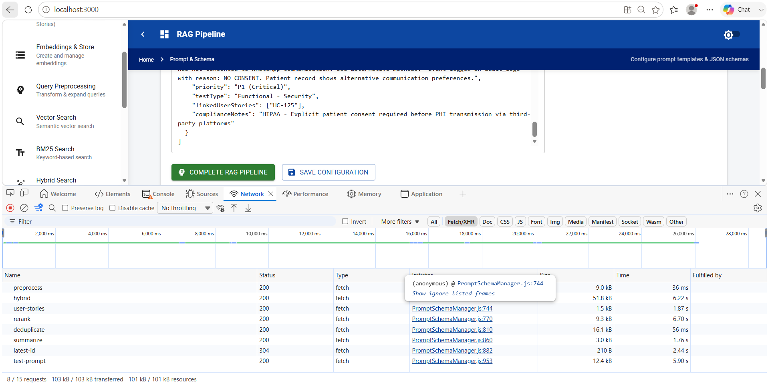
Step 2: Testcases Retrieved
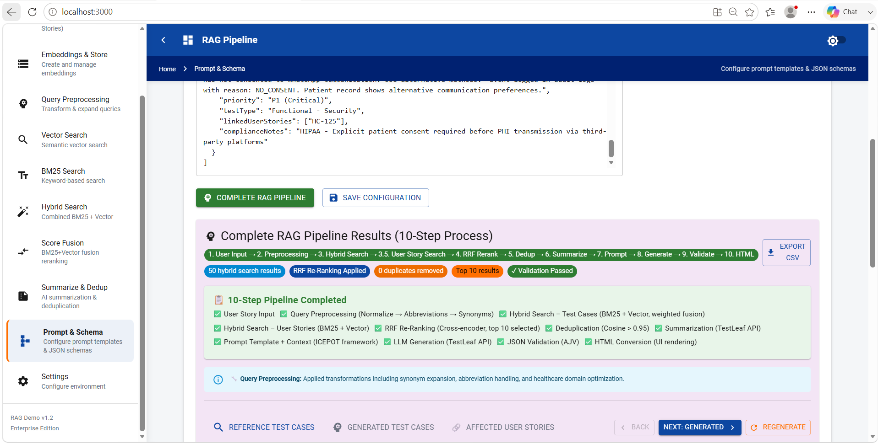
Step 3: When the Testcase is selected and when the network call is done
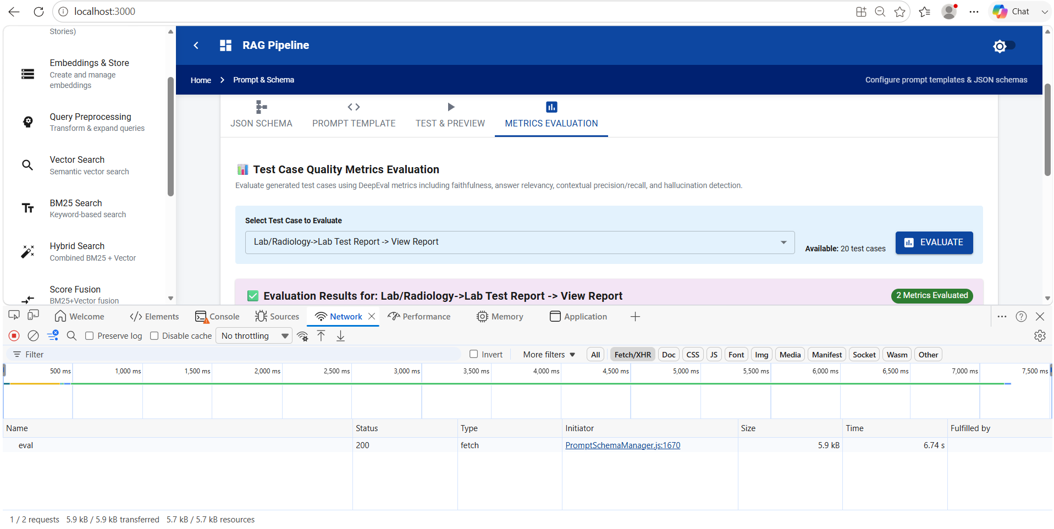
Step 4: The metric evaluated against the testcase.
